1. 
2. **Agenda**:
   1. Will study advanced commands which modify Git History.
   2. It means those commands are destructive commands.
   3. Use them pre-causations especially with public branches (master, develop, release branches).  
      As these branches are checked out by different developers and if you make any changes to git history,   
      **unexpected result may occur**.  
      But if you’re working on your private branches without other collaborators, then you can use these commands safely.
3. **reset Command**:
   1. Used to discard commit changes.
   2. **Different Options**:  
      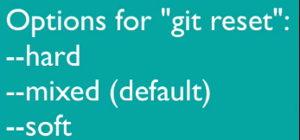  
      Based on a specific selection from the above, the different changes would be applied (Working Area, Staging Area, Git Repo)
4. Let’s take pull to synchronize the local and remote repo.
5. 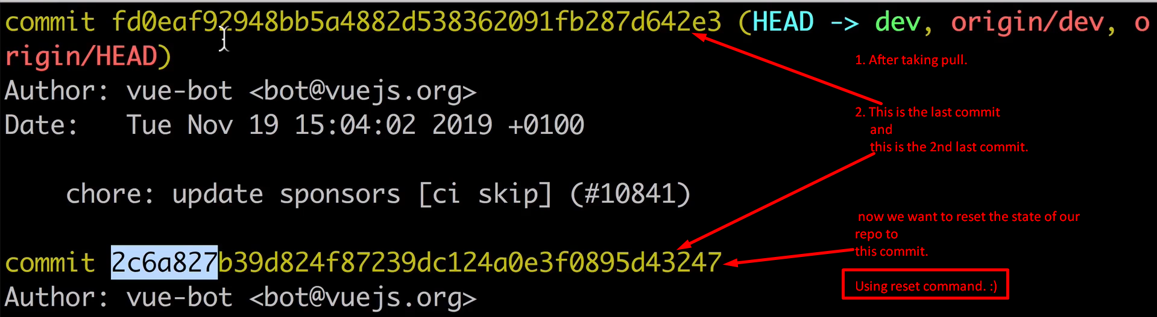

**NOTE**: Actually, we can reset git state to any previous commit.

1. 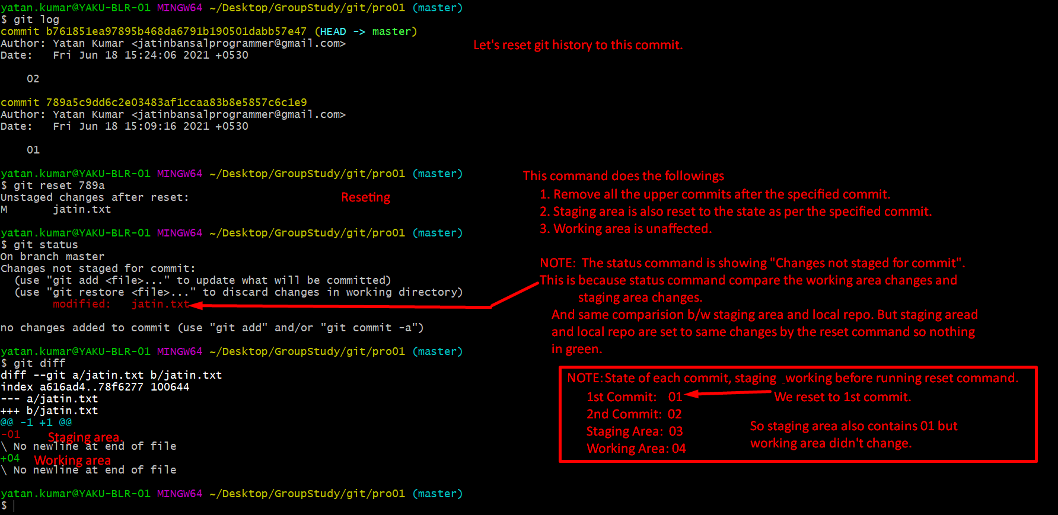
2. 
3. 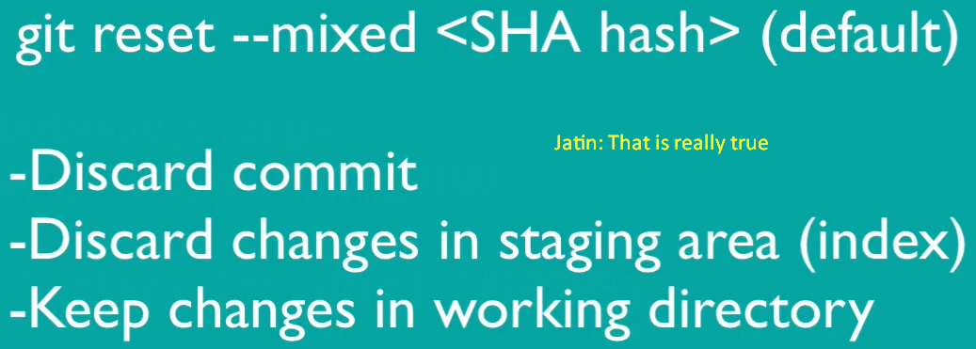
4. 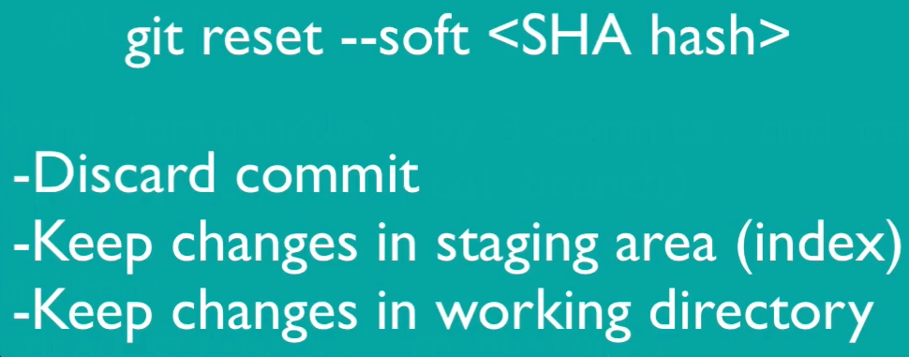
5. 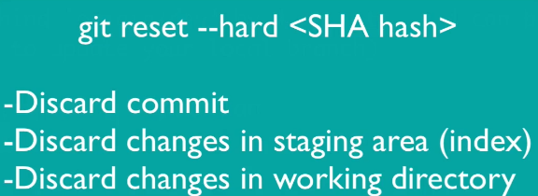  
   This is most destructive operation.
6. **NOTE**: If you do “git reset”, any out of those 3 (mixed, soft, hard), the commits are removed from your local repo only.
7. Command 🡺 git reset HEAD~2 🡺 To remove last two commits from the Top 